Timeline
The Coronavirus pandemic has resulted in the world of the sports industry to grind to a halt as every countries government all over the globe seeks to toughen measures to curb the spread of this contagious virus. Here is a timeline of how sporting events in last three months have been panned out and the resultant effect of COVID-19 to the sporting industry: on 22nd January the football qualifiers for women's Olympic was moved from Wuhan province in China to Nanjing, and later on to Sydney. On 30th January the Chinese Football Association postponed all indoor games due to Coronavirus. On the 23th February, series A matches of northern Italian regions of Veneto and Lombardy were put on a hold as well as Series B and D were also called off. On 8th March UEFA bans, handshakes in all of its pre-matches as all sporting event in Gabrovo and Pleven are postponed. On the 14th March all football events are suspend in Morocco it further notice. On 24th March Japans Prime Minister Shinzo announced that due to the coronavirus pandemic the International Olympic Committee has agreed to postpone the Tokyo 2020 Olympics till next year.
As of a sportsman, I have been able to learn how to cope with a win and a defeat when a season ends. However, with the ongoing uncertainty, I have been forced to confront a new form of disappointment, losing a season. Apart from not being able to engage in any real sporting tournament, there is the restriction of staying at home and moving out when it's necessary. The restriction of movement hinders my growth has an athlete as I can no longer jog or even go to the gym. All am left with are the thought of what could have been and why is this happening. I have watched and read material encouraging me to focus on the things within my control, but then again, it's not as simple as its put in theory. Most athletes break even with their careers while in college, the thought of losing a season while in college is disastrous. The again sports teaches to overcome anything that is thrown our way, resilience.
Maps/Graphics
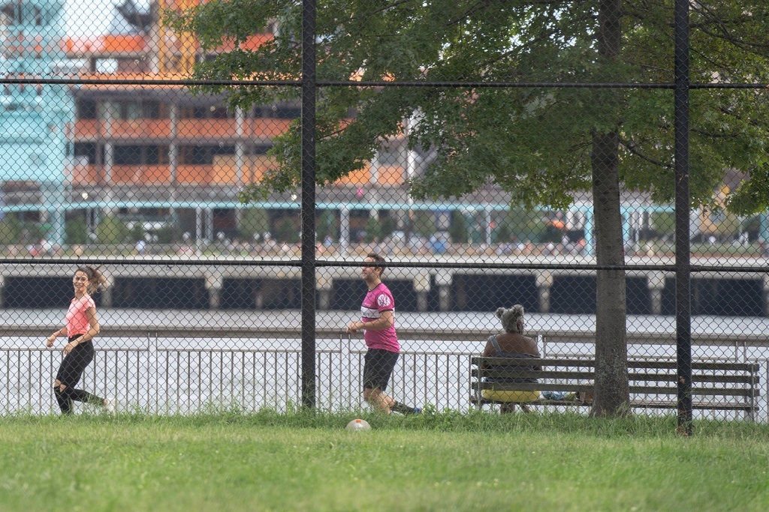
The sight of this image from the New York Times describes the exercising situation athletes and everyone who wishes or used to jog are experiencing. Before the virus individuals used to jog side by side while encouraging each other, however, with on-going COVID-19 situation, one is only left to wonder. The first day I went jogging after the coronavirus pandemic I was on the internet searching on how long the virus remains in the air. The answer to the previous question is never assuring as one doctor Iwasaki from the New York Times responded “the wind doesn’t disperse the germ. However, this scenario is unlikely to spread the virus but cannot be termed as impossible.” With such an answer am only left with the thought of buying a windmill and postpone jogging till further notice.
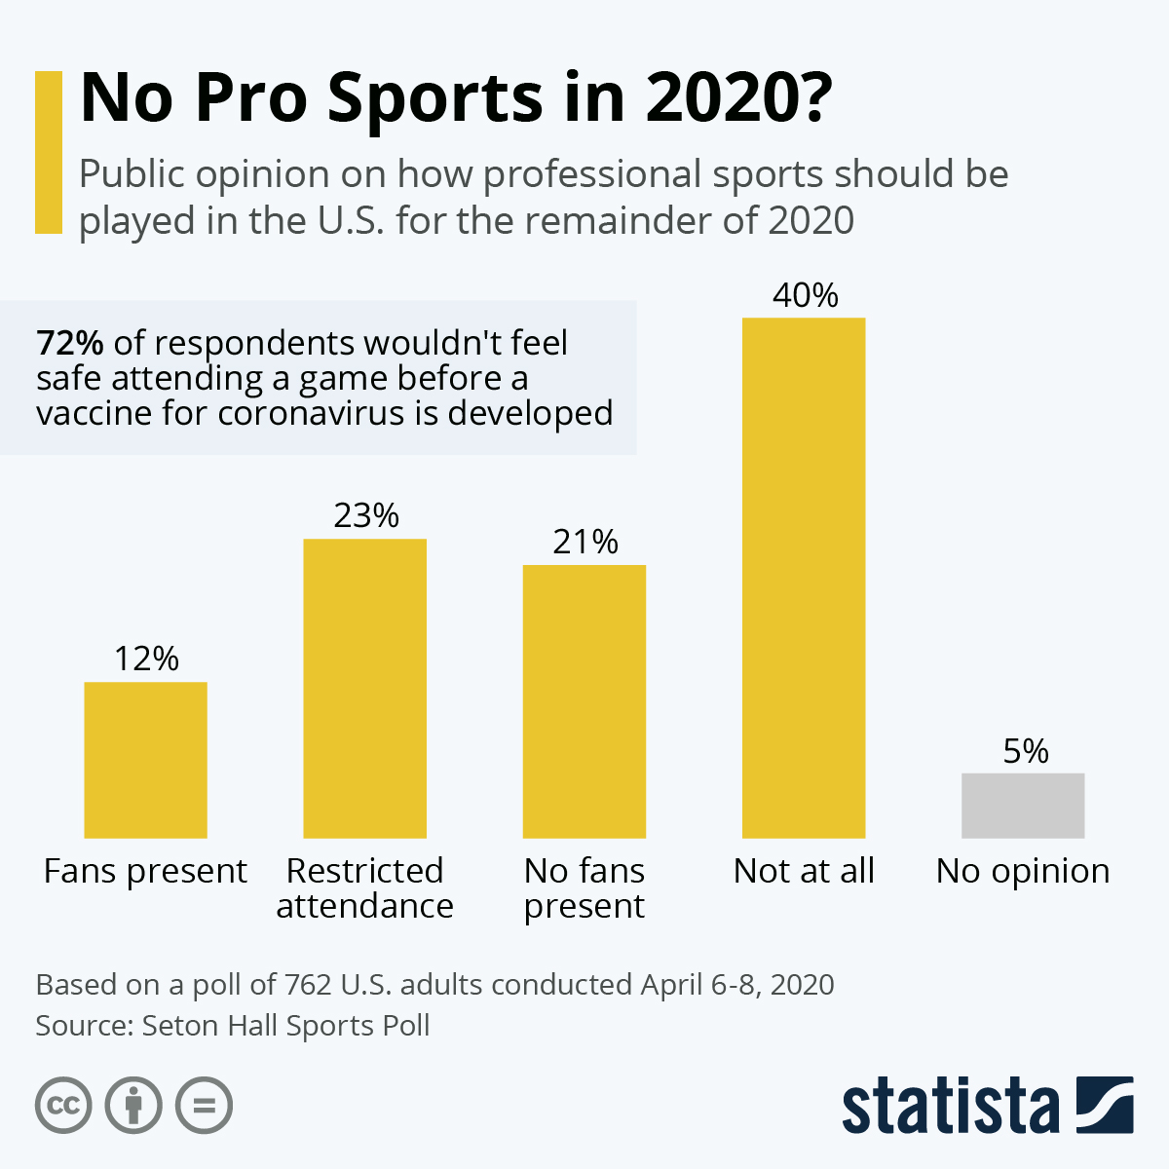
The above grapgh is from the Statista website that demonstrates fans reaction and reasoning behind attending a sporting event before the coronavirus has been found. The graph shows that over 40% of Americans would are against any professional sport being held before the pandemic is over. A small number totalling to 23% of all that were sample can attend only if their attendance is done with restrictions. From this graph one can tell that the difficulties athlete are going through now are not going to end soon. Governments have started allowing the opening up some businesses like hotels and those too are complaining of the traffic. The latter demonstrates that even after coronavirus is over, this will be different, it is likely for the worst.
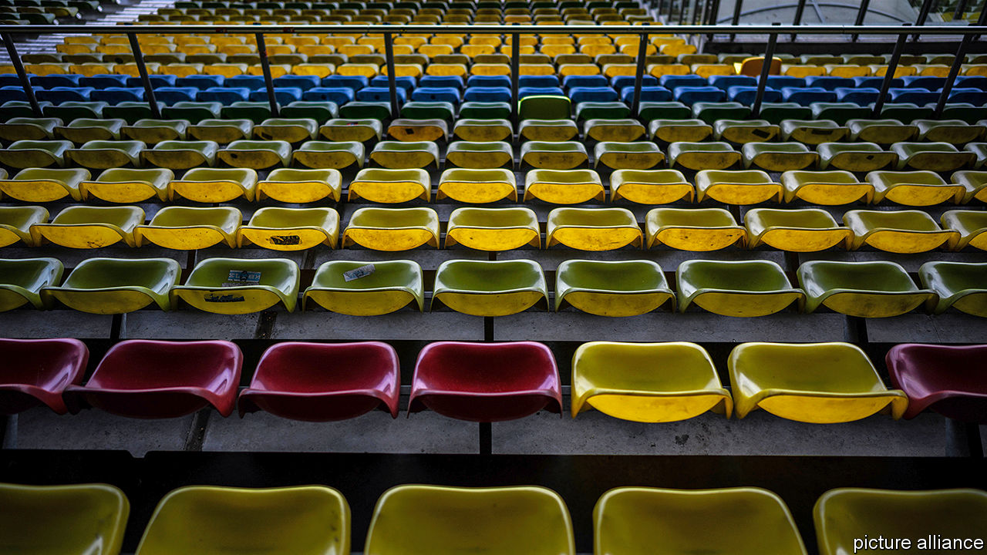
The above picture is from The Economist magazine showing empty seats in a stadium. The image shines a light into the economic impacts this pandemic has caused to the sporting industry. In the recent past, the local and global sporting tournament has been cancelled while some have been modified all of these has happened without notice. NHL has suspended the season, MLB cancelled its spring training, and the master's golf tournament has been postponed. All of these empty seats symbolises lack any activity in the stadia which directly relates to the employment factor without attendance teams and competition cannot be able to pay their players and staff as well as support upcoming talent. As per my opinion, this signifies loss of the most precious resource that cannot be recovered, time. With the empty seats would not help but wonder is a career in athletes sustainable? Is it essential or just a form of entertainment that the world can do without?
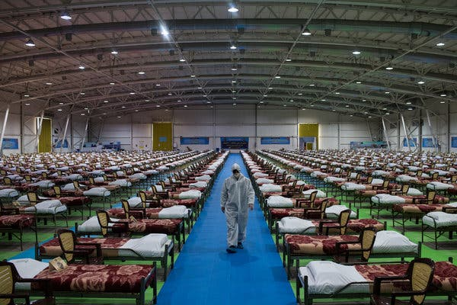
Above is a picture of a temporary hospital in Tehran in Iran. With the massive number of beds, it’s clear that the COVID-19 virus is a severe pandemic that has proven to the world of its unpreparedness to such an epidemic. From the number of beds present in the temporary facility, it is accurate to note that the health system of Iran has been overwhelmed. Iran’s president was among the head of state that made an announcement to its people implying that the virus was a bioweapon the country’s enemy was using to bring them down. With current statistics of infected persons in Iran, it is evident that the virus is not the only problem but also misinformation. The World Health Organization has had to take charge of the spread of coronavirus information to avoid people getting the wrong information. With the current state of misinformation from head of states who are have the states machinery at their disposal makes it difficult to trust anyone, what could they have misunderstood or hiding from us which is a clear indication that the pandemic is far from over or maybe our lives will never get back to normal.
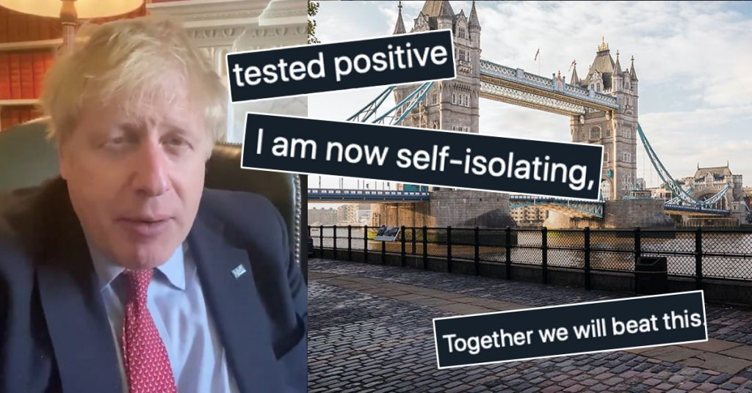
Above is a photograph is from the lovinmalta.com website recent. It shows that Boris Johnson, the Prime Minister of the United Kingdom testing positive of coronavirus. No one is immune of the virus ant that it does not discriminate along any line be it social status in the society, race, gender, religion or any other. It is only wise to be safe I had read articles that argued African Americans, and those from Africa are immune of the, but that was another poorly thought assumption as from those that have succumbed to the virus cut across every race. Boris Johnson contracting the virus shows how lethal COVID-19 is, and everyone needs to take safety precautions. On hearing the news on Boris Johnson, I panicked and realised no one is safe.
Secondary Sources
Barry, J. M. (2005). The great influenza: the epic story of the deadliest plague in history.
This book examines the 1918 influenza pandemic, and it describes the flu to be one of the worst epidemics to have hit the history of the world. The author John Barry focuses more on what happened in the United States as he explains how it affects the political, economic, sports, and social realms of the country as he places it in the context of the history of medicine. Just like COVID-19 during the influenza pandemic, dramatic measures were put in place to tame the flu from spreading. As a result of the flu epidemic, the FA Cup and Football League postponed did not take place as of between 1915 to 1919. In America, a Major League Baseball player died as a result of the flu making the college football games to be canceled. The limitation of using the Great Influenza source is the fact that influenza had an incubation period of 4 days while coronavirus has a 14-day incubation, which makes it difficult to spot and curb it from the spread as compared to seasonal influenza flu. Another limitation is that during the Spanish flu pandemic, some sporting events were taking place; however, with coronavirus, no event is allowed to take place.
Rosen, W. (2007). Justinian's Flea: The First Great Plague and the End of the Roman Empire. Penguin.
The book covers the Bubonic plague, a pandemic that is believed to have happened between 541 to 542. The death toll from the Justinian plague is approximated to be 25 million. The epidemic is recorded to have been killing 5000 people in a day in which, at the end of it all, it had killed over a quarter of the world's population from the Mediterranean. The effects of the Bubonic plague resulted in the economic decline of the Byzantine Empire. The decrease was directly related to the mortality rate, which caused a shortage in the labor supply. It is the plague of Justina that made the Roman Empire weak if it had not happened; Rome would still be administering its entire economy. The limitations of using this source are the fact that technology was as advanced as it is currently. The fatality rate of coronavirus in the present day would make it a more dangerous virus if it happened a century ago.
Benedictow, O. J., & Benedictow, O. L. (2004). The Black Death, 1346-1353: the complete history. Boydell & Brewer.
In this book, Benedictow uncovers the historic black death plague that had ravaged Asia, Europe, North Africa, and the Middle East between 1346 and 1353. The author analyses the several consequences the disease brought upon its people; these include economic, religious, and cultural influences. It is during the Black Death epidemic in the 14th century that the Europeans started struggling with religion. Before the plague, they always hoped that faith through the church could save them from anything. However, the epidemic disputed this claim; it forced them to question their belief system. Just like in the Justinian plague, no one knew the origin of the disease, not even the doctors hence the over-reliance in supernatural powers. The limitations of the Black Death source, in contrast to COVID-19, are that they never found the cure the disease just disappeared. The reason for this was high on the fact that they never knew the origin of the disease. In the fight against coronavirus, the current world is at an advantage as it has already identified the source of the virus, and the over-reliance on supernatural powers is non-existent.
Primary sources
Keane, S., 2020. Elon Musk Tweets Criticism Of Coronavirus Lockdown. [online] CNET. Available at: <https://www.cnet.com/news/elon-musk-tweets-criticism-of-covid-19-lockdown/> [Accessed 29 April 2020].
This is an article from the Cnet.com that articulates on Elon Musks tweet that referred the lockdown to be dumb. In the piece they have started by showing Elon Musk thinking process of how the lockdown is only hurting business his included and not solving its intended purpose. From my point of view this is selfish of him to trashgovernments initiatives that are intended to help curb the spread of the diseases when Americans themselves have experienced the ramifications of not following these guidelines through the skyrocketing numbers in infections and deaths.
Zucker, J., 2020. Timeline Of Coronavirus' Impact On Sports. [online] Bleacher Report. Available at: <https://bleacherreport.com/articles/2880569-timeline-of-coronavirus-impact-on-sports> [Accessed 29 April 2020].
This news article from the Bleacherreport.com shows an outline of how Coronavirus has affected the sporting world. The report covers almost every sporting event that was canceled or postponed as a result of Coronavirus. It captures the name of the game, date and time of the event, and the actual time the announcement for its cancellation happened. From the list provided, I discovered that I am not the only athlete out there struggling with the abandonment and lack of actual practice with fellow team members the whole sporting world across the globe has been affected. All we can do is hope that a solution is found .
Twitter Bans Misleading Coronavirus Information. [online] Available at: <https://www.reuters.com/article/us-health-coronavirus-twitter/twitter-bans-misleading-coronavirus-information-idUSKBN21603I> [Accessed 29 April 2020].
The article from Reuters covers on how twitter intends to address the subject on the spread of misleading information on twitter. Twitter will be barring misleading information from its users; this means it has tightened its policy on rules on speech. On my end, I find this move by twitter to be highly helpful in fighting coronavirus. Everyone in society has a role to play, and this is what Twitter should have done a long time ago, even before corona.
Who.int. 2020. Coronavirus. [online] Available at: <https://www.who.int/health-topics/coronavirus#tab=tab_1> [Accessed 29 April 2020].
The above article is from the World Health Organization on how coronavirus spreads, the viruses symptoms, preventive measures, and everything there is to know about the virus. I find the article useful as given it’s from a credible source, whenever I read new information about the disease from somewhere I always reference it what the World Health Organization is.
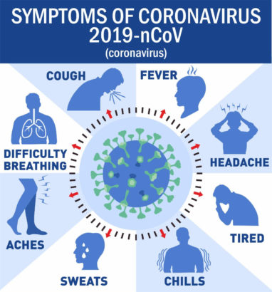
Above is a simplified image from the Center of Diseases Control on the symptoms of COVID-19. The symptoms shown in the image are the seven most conspicuous symptoms of the coronavirus. From the image it’s quite easy to know if an individual needs to be tested thus if you have all of the symptoms simultaneously then you should self-isolate yourself and go for a screening.
Lived out Commentaries
I am a subscriber of the Daily Show by Trevor Noah. Since the onset of the coronavirus pandemic, the Daily Show has indeed shown significant change over time both in the news chronological timeline and setting. On the March 17, Trevor Noah covers news on how Donald Trump faults the European Union and suspends travel to Europe. On March 25 through YouTube, the daily show reports on the updates and hosts D.J. D-Nice on the creativity of social distancing. On April 3 Trevor Noah interviews Bill gates on when the virus could come to an end and what measures are being taken to release its vaccine. In the interview, the pandemic had not hit America, and the concept of Deejaying on Instagram was new, and the conversation was happening from the central comedy studios. On April 17 Trevor Noah Interviews his colleague Ronny Chieng who got stuck in Australia because of the measures that the country set. On the 29TH of April, Trevor hosts the show from his home when covering the news on Paycheck to protect the program. At the time of the last interview, the coronavirus epicenter had shifted from China to the United States, hence the reason why Trevor was hosting the news from his home.
The second commentary that is a subscriber of is the Guardian online news blog. From the usual email newsletter, one could create a timeline of how the coronavirus pandemic has progressed from its day one. On March 2 New York reports are 1st case of COVID-19 of a woman who was in her mid-30. March 3rd Ohio governor cancels the Arnold Classic due to coronavirus fears. On March 7 the guardian reports of Washington D.C.D.C., Kansas, and Virgin first cases as it raise the number of those who have succumbed to Coronavirus to 19 in the United States. On March 12 The Guardian reports of 2100 cases as Colorado reports its first case. As of March 20, the total confirmed cases of COVID-19 adds up to 19,285, with 249 deaths as reported by The Guardian. On March 26 the magazine reports that the United States of America confirmed cases had surpassed China, making the U.S.A. the epicenter of the diseases. On April 8, the United States' death toll becomes the highest in the whole world with a total.
Timeline YouTube channel is the third commentary that I have subscribed to, and here is their timeline on the coverage of the news. On January 31, January 31, Spain is reported to have its patient zero of COVID-19, who was said to be a tourist in Canary Island. The YouTube channel on February 9 reported Spain's second patient, who is said to be a British male, also a tourist. On February 25, the new four cases are reported; this totaled the number to 3 confirmed cases. On March 13 Spain’s Prime Minister Pedro Sanchez announces a nationwide state of alarm for 15 days as the confirmed cases total to 4231. On March 28 Spain's government bans all of its non-essential services as the number of confirmed cases amount to 72,248

